Title: IS-LM
Subject: MACRO 4
Assumptions
i. SR sticky prices
ii. Producers accommodate Consumers = Output follows Demand. This is due to the fact we assume we are in the SR and prices are sticky: producers cannot adj P immediately, they will have excess/dearth of Demand for their products. In the LR they will adj their p wrt abundance of factors of prod such as L and K = Yn

ASSET MARKET
GOODS MARKET
1. External Market: Individuals are indifferent
btw local and foreign deposits. Foreign exch
market is in eq if $R=R^{*}+\frac{(E^{e}-E)}{E}$ (UIP)

2. Internal market eq: Individuals are indifferent
btw holding deposits or bonds. Money mkt is
in eq if $\frac{M^{S}}{P}=L(R, Y)$

1. Aggregate Demand of Goods
a. Consumption Demand
C = c(Y^{D})
b. CA Demand (imagine depreciation)
CA = EX – IM, all in real terms: units (volume) of domestic or foreign goods and services
EX = $\frac{Nom Val of exp in dom cur}{P}$ = $\frac{\left(units of exp\right) * P}{P}$ = u of exp (RER)
IM = $\frac{Nom Val of imp in dom cur}{P}$ = $\frac{\left(units of imp\right) * EP^{*}}{P}$ = u of imp (Y^{D}, RER) * RER

2. Supply (OUTPUT) of Goods
As we have said, supply accommodates demand!

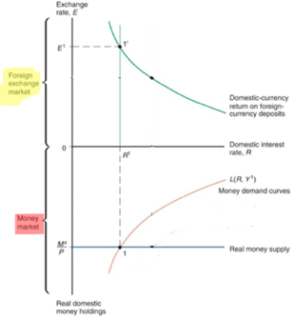



(1) + (2) Equilibrium in the goods market:
In our model S accommodates D! this means S funct
must be a 45° line st Output (supply) = AD => Eq. is where:

Y = C (Y - T) + I + G + CA (RER, Y - T)

In cases of disequilibrium (2 or 3) firms will adjust prod
to meet AD
(1) + (2) Equilibrium in the Asset market

eq is where:

$\left\{\begin{aligned}R=R^{*}+\frac{(E^{e}-E)}{E} \\ \frac{M^{S}}{P}=L(R, Y)\end{aligned}\right.$ => substitute R: M^{s}/P = L (Y, R* + ((E^{e}/E) - 1))

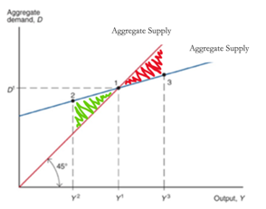

3. The AA Schedule
This eq condition provides an implicit relation btw
Y and E (nominal).
If Y $↑$ -> ceteris paribus, M^{D} shifts right => i $↑$ => E $↓$
to make UIP hold. THIS IS ABOUT A MONEY MKT
EQUILIBRIUM

We can build a full set of combinations Y-E st the
overall Asset mkt is in eq (home return = foreign
return) = the AA schedule*!
- Explain Downward sloping + excesses (two cases):
i. You are in 1, Y↑ -> ceteris paribus you are in 1’,
output increase means right shift in M^{D} = excess money
demand => higher interest rate
=> i increases and E appreciate

3. The DD Schedule
The Eq. condition provides an implicit relation btw
Y and E (nominal).
If E ↑ -> ceteris paribus, AD shifts up -> Y↑

We can build a full set of combinations Y-E st the goods
mkt is in eq = the DD schedule!
- Explain Upward sloping + excesses (two cases):
i. You are in 1, Y↑ -> ceteris paribus you are in 1’, higher
output is not fully compensated by higher domestic C
(leakage: imports, saving)
excess supply of goods => E must $↓$

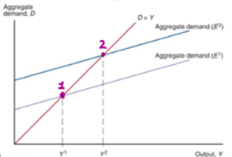
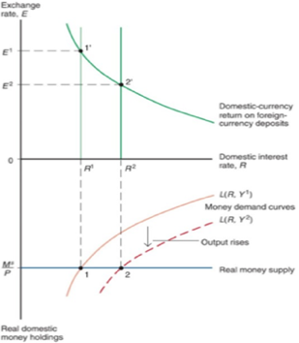

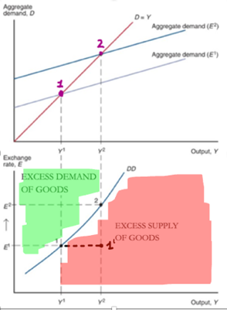

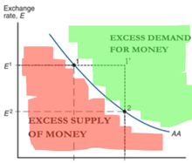

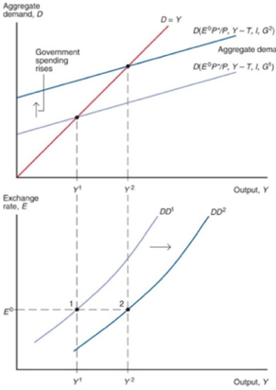
I. Shifts in the AA: Anything except 𝑌 and 𝐸 shifts:
M^{s}/P = L (Y, R* + ((E^{e}/E) - 1))
Bottom panel: Imagine Y must be kept fixed, and consider what happens to E as green and reds move. Event => channel => effect on y. If event leads to higher E we have an up shift.

Exs
1. If M^{S} $↑$ => i $↓$ => E $↑$ (graph)=> the AA right.
2. An increase in P. Real money supply fall => …
3. An increase in the expected depreciation => the current exchange rate depreciates (mi conviene quindi vendo e compro) => AA shifts up.
4. Contractionary Change in asset-holding preferences = left shift in money demand => AA shifts up

I. Shifts in the DD: Anything except 𝑌 and 𝐸 shifts:
Y = C (Y - T) + I + G + CA ($\frac{{EP}^{*}}{P}$, Y - T)
Bottom panel: Imagine E must be kept fixed, and consider what happens to Y as green and reds move.
Event => channel => effect on y. If event leads to higher Y we have an up shift.

Exs: explain Event => channel => effect on y => shift
- P ↓ => Dom goods relatively less expensive given E =>
D for dom goods ↑ => Y↑ => DD shifts out
- Savings rate ↑ => C ↓ => Y↓ => DD shifts in
- Preferences towards foreign goods ↑ => Dom goods relatively less attractive than Foreign goods => D for dom goods ↓ => DD shifts in.

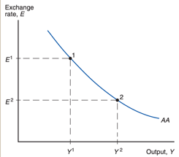
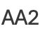

*In all of these graphs you can end up in zones of excess supply/demand for different reasons (internal or external) => opposite consequences

GENERAL EQUILIBRIUM
Assume: Ee, R*, P* and P are Fixed.

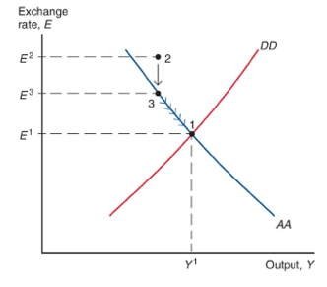
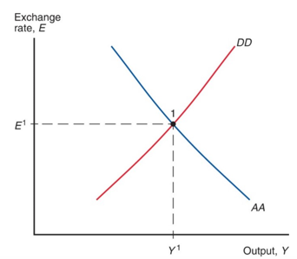

What are the forces that drive the economy towards this eq?
i. 2: Here both markets are out of eq: there is excess demand for the
domestic currency and excess demand for domestic output.
ii. the fin market reaches equilibrium immediately; the goods
market takes more time => from wherever we are, we go
immediately and "vertically" to the AA curve (excess demand of money
=> higher interest rate => E appreciates);
iii. then the excess demand for goods causes producers to produce more
and absorb the excess demand, as we move along the AA curve.

SHIFTS: extensively in the FE file

Because temporary mp / fp expansion both raise output and employment, they
can be used to counteract recessions. Note: monetary and fiscal expansions have
similar effects on output, but opposite effects on the exchange rate.

Problems of this approach:
1. A Gov can be tempted to use fp and mp to expand demand and output. But ... this can lead to inflation. Anticipating an increase in p, workers will demand higher w => firms will increase p => lower exports => This reduces AD and causes the DD curve to shift in => to avoid recession gov forced to validate the expansionary expectations = macroeconomic policy can display an inflation bias, with high inflation but no gain in output (Us 1970s). Independence and IT is key in convincing market actors.
2. Problems related to information, decision (persistent or temporary shock?) and lags
3. Fiscal policy has an impact on gov budget and debt

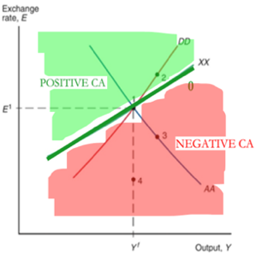
What are the effects of macroeconomic policies on the CA?

Base: define the XX

We can now examine the CA effects of macroeconomic policies.

XX: combinations of exchange rate and output st the CA would be equal to 0. Recall CA(Y^{D}, RER). Use XX as a benchmark to understand if at equilibrium AA = DD the CA is positive or negative

- XX slope is positive and flatter than DD. Start from point 1.
-- DD is in eq when S (output Y)= D. Now, if we increase Y in moving up along DD, the domestic demand for domestic output rises by less than the rise in output itself (since to two leakages: income and imports) => need depreciation to compensate for these two leakages
-- XX is in eq when IM (Y^{D}, RER)= EX (RER), as Y raises by 1 (Y $↑$) , Import leakage (IM ↑) => CA ↓ (it falls below X) => must compensated by deprecation E ↑.

iii. Permanent fiscal expansion => 4, same output but appreciation. Since 4 lies below XX, the CA is negative, and more than before
ii. Temporary fiscal expansion=> 3, higher output and a appreciation of the currency. Since point 3 lies below XX, the CA is negative

i. Temporary Increase in the money supply => 2, higher output and a depreciation of the currency. Since point 2 lies above XX, the CA is positive

